TABLE TENNIS
A Brief History:
Table Tennis is a direct descendent of the game of royal tennis. Most historians believe tennis began in the 12th century when French monks played a game they called “jeu de paume” [game of the hand]. The monks would call out “tenez” [Take this! Or Play!] as they hit the ball at their opponent to start the game. The original ball was made of wood and later, the ball was a wad of hair, wool, or cork wrapped in string and cloth or leather. The game was played indoors with players hitting the ball into door jams and other imperfections in the walls strategically trying to outwit their opponent. The “net” was usually a rope tied across the court five feet high at the sides and drooping to three feet at the middle. The game was played at first with the hand and as time passed gloves were used, then paddles with webbing, and eventually a handle was added to form a primitive racket. Through the 18th century, the game was very popular in France with most noblemen and royalty taking to the game. At this time the game was called “royal tennis” or “Real Tennis” and it was played indoors.

The game of tennis as we know it today started in 1850 when Charles Goodyear invented a vulcanization process for rubber and the bouncing ball was invented. People began experimenting by playing the game outdoor on grass. In 1874, Major Walter Clopton Wingfield patented the game “Lawn Tennis” [“Modern Tennis”] and its rules. The original court was an hourglass shape and many of the rules were troublesome. Many rule changes took place over the years but by 1882 the court, net, and rules of play had become standardized.
By the late 19th century [1880’s] members of the upper-middle class in England started playing their own version of Lawn Tennis after dinner on the dining room table. This was the start for what would later be called Table Tennis of Ping Pong. Others claim that the sport was once known as indoor tennis, and was played in the early 1880's by British army officers stationed in India and South Africa. The officers used cigar box lids as paddles, rounded wine bottle corks as balls, books for an improvised net, and was played on table tops. There is plenty of evidence to support both claims.
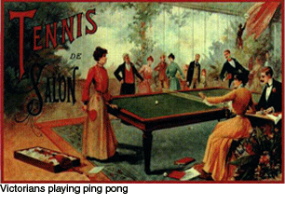
During the late 19th century the game was called by many different names – Whif whaf, flim flam, gossima to name a few. However, neither David Foster’s “Parlor Table Game” nor John Jaques’ version he called “Gossima” caught on because the cork ball did not bounce enough and the rubber ball bounced too much. The game faded in popularity until 1900 when James Gibbs brought the celluloid ball back to England from the United States. In 1901, Jaques changed the name of his game to “Ping Pong” because of the distinctive sound the ball made when it was hit back and forth and obtained a registered trade name in England. The rights to the name “Ping Pong” were than sold to Parker Brothers in the United States. Then in the 1920's the name and the sport were revived in Europe as table tennis.
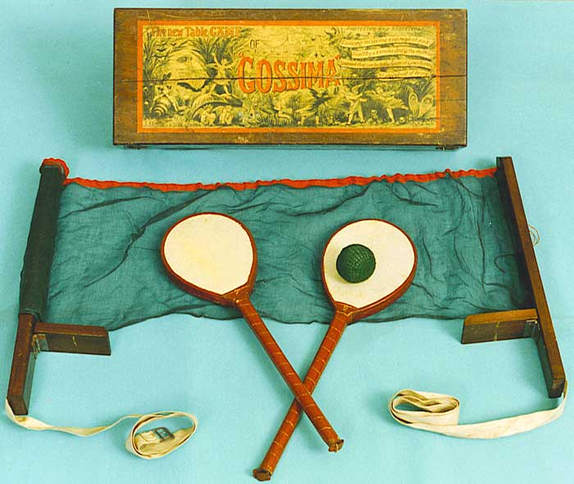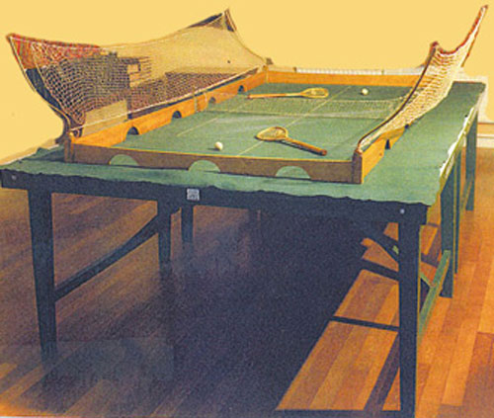
Table Tennis Rules -- A Little History:
The rules of the game have changed and evolved over the years. In 1903, E.C. Goode replaced parchment paper and cigar box lids with pimpled rubber on light wooden “blades” as rackets. After the world championships in Prague in 1936, where two defensive players took over an hour to contest one point, the net was lowered to make the pace of the game-play faster. In the 1970’s table tennis players discover that using bicycle tire repair glue to put rubber on a blade dramatically increases the speed and spin that can be produced on the ball. This discovery is often credited to Dragutin Surbek of Yugoslavia and Tibor Klampar of Hungary and was referred to as speed glue. The twenty-first century brought about more changes to the sport. The International Table Tennis Federation [ITTF] increased the ball diameter to 40mm and changed the scoring system, moving to an 11 point game, and using a best of 5 games or best of 7 games as a match; all in an attempt to make the sport more entertaining and faster paced. Frictionless long pimples on rackets became popular among many players as we moved to the new millennium, in an attempt to negate the power and spin produced by modern technology and speed glue. Then by 2007 the ITTF announced the banning of frictionless long pips and speed glues.
How to Hold the Racket: There are two widely used grips.
Shakehands Grip –
This grip is the prevalent grip in table tennis (as of 1998), used by the majority of recreational and professional players. The paddle is gripped with all fingers, with the thumb resting by itself on the opposite side as the index finger. The grip is analogous to shaking a hand at an approximately 45-degree angle. The pinky, ring, and middle finger wrap around one side of the handle, and the index finger rests on the bottom edge of the rubber. The thumb rests on the top of the handle on the other side, thumbnail perpendicular to the wood. It should point in the same direction as the index finger. When held out straight in front of you, the paddle's edge should form a line with the outstretched arm. The grip should feel natural, with no particularly uncomfortable areas. Too tight a grip can sacrifice control and power. Be sure to grab the handle loosely enough so that another person would have no trouble plucking it from your hand. But at the same time, maintain enough tightness so the paddle won't fly out of your hand during an intense shot.
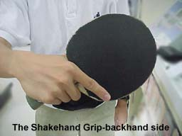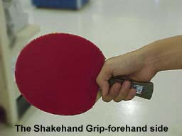
Some of the advantages of using the shakehands grip are:
- Equally strong forehand and backhand advantage (provided you pay equal attention to both).
- Wide selection of paddles to choose from.
Penhold Grip –
Once was the dominant grip in its heyday. The penhold grip still has its supporters, world class players included. The racket is gripped as one would grip a pen, with the thumb and index finger, with the rest of the fingers being tucked away on the other side. There are several variations to this grip, and two types of paddles to reflect this. The "chinese" paddles are basically shakehands paddles with a shortened handle. The remaining fingers rest against the other side. "Japanese" paddles have a raised handle, which is called a "hook." The index finger curls around the "hook" for extra leverage. Which one you use depends on personal preferences. Penhold paddles typically only have one side covered with a rubber sheet. This makes them lighter than most shakehands paddles. The other side must still comply with the paddles rule, so it is usually painted red or black, or covered with a sheet of colored paper.
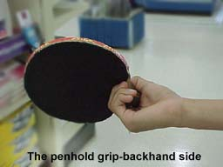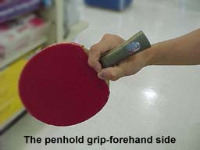
Some of the advantages of using the penhold grip are:
- A dominant forehand game (while backhands are possible with this grip, the vast majority of penhold players rely on their forehand game)-quick feet are required to sustain this!
- Since it is not as widely used, an element of surprise against opponents unfamiliar with the grip

Rules of the Game: The basic rules to play a friendly match of ping pong.
Scoring
A match is played best 3 of 5 games (or 4/7 or 5/9). For each game, the first player to reach 11 points wins that game, however a game must be won by at least a two point margin.
A point is scored after each ball is put into play (like rally scoring in volleyball).
The edges of the table are part of the legal table surface, but not the sides.
It is a loss of point if either player volleys the ball during a rally.
Flow of the Match -- Singles
Each player serves two points in a row and then switch server. However, if a score of 10-10 is reached in any game, then each server serves only one point and then the server is switched. After each game, the players switch side of the table. In the final game (ie 5th game), the players switch side again after either player reaches 5 points.

Flow of the Match – Doubles
The player on the right side serves on an angle to his opponent on the right side [diagonally across the net]. The return of serve must be played by the server’s partner and his shot must be returned by the second opponent. To simplify – player alternate taking shots; you can never hit the ball twice in a row. Each server serves two points in a row and then the serve goes to the opponents. After a player finishes serving he/she switch positions with their partner [players should never serve/receive from the same opponent if you are rotating properly]. In doubles, at each change of service the previous receiver shall become the server and the partner of the previous server shall become the receiver. If a score of 10-10 is reached in any game, then each server serves only one point and then the server is switched. After each game, the players switch sides of the table. In the final game (ie 5th game), the players switch side again after either team reaches 5 points.

Legal Service
The ball must rest on an open hand palm. Then it must be tossed up at least 6 inches and struck so the ball first bounces on the server's side and then the opponent's side.
If the serve is legal except that it touches the net, it is called a let serve. Let serves are not scored and are re-served.

BASIC STRATEGIES
- Serve as short on the table as possible, then place the next ball as deep as possible (this forces your opponent to move in and out quickly, one of the most difficult things to do).
- Keep placing the ball to your opponent’s elbow (this forces them to move to the side in order to hit the ball).
- Place the ball all over the table, to discover if your opponent has a weak spot where they have trouble getting to or stroking the ball (then hit to that spot repeatedly).
- Change the spin on the ball to surprise your opponent and make them hit it into the net or pop it off the end.
- Change the pace of the ball from slow to fast, to surprise your opponent into making a mistake.

BASIC STROKES/SHOTS
Defensive Shots:
Block Shot -- This shot would normally be used when the approaching ball is moving very quickly towards you with heavy topspin and the purpose of this stroke is to catch your opponent out of position and reduce the time available for them to play their next shot. A block is executed by simply placing the racket in front of the ball right after the ball bounces; thus, the ball rebounds back toward the opponent nearly as fast as it came to you. Blocks almost always produce the same spin as was received, usually topspin.
Push [Chop] Shot -- The push (or "slice" in Asia) is usually used for keeping the point alive and creating offensive opportunities. A push resembles a tennis slice: the racket cuts underneath the ball, imparting backspin and causing the ball to float slowly to the other side of the table.
Lob – A shot where the ball is returned very high in the air and deep on the table. This shot is used to slow down play against high-speed shots.
Offensive Shots:
Drive Shot-- The primary offensive shot in table tennis that produces light topspin. Executing this stroke the racket is primarily perpendicular to the direction of the stroke creating a shot that does not arc much but is fast enough that it can be difficult to return. A drive is used mostly for keeping the ball in play, applying pressure on the opponent, and potentially opening up an opportunity for a more powerful attack.
Flick -- Hitting a ball early making contact over the back or top of the ball using a loose wrist action to impart topspin.
Smash [Kill] -- Smashing is self-explanatory—large backswing and rapid acceleration imparting as much speed on the ball as possible. A player will execute a smash when his or her opponent has returned a ball that bounces too high or too close to the net. The goal of a smash is to get the ball to move so quickly that the opponent simply cannot return it. Because the ball speed is the main aim of this shot, often the spin on the ball is something other than topspin. Sidespin can be used effectively with a smash to alter the ball's trajectory significantly.
Equipment
The paddle should have a red and a black side. The ball should be either orange or white and 40 mm in size. The table should be 2.74 meters long, 1.525 m wide, and 0.76 m high.
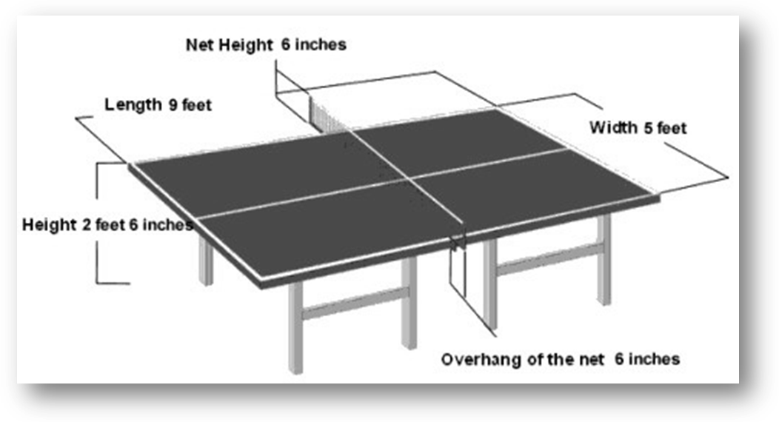

Official ITTF Rules -- THE LAWS OF TABLE TENNIS
2.1 THE TABLE
2.1.1 The upper surface of the table, known as the playing surface, shall be rectangular, 2.74m long and 1.525m wide, and shall lie in a horizontal plane 76cm above the floor.
2.1.2 The playing surface shall not include the vertical sides of the tabletop.
2.1.3 The playing surface may be of any material and shall yield a uniform bounce of about 23cm when a standard ball is dropped on to it from a height of 30cm.
2.1.4 The playing surface shall be uniformly dark coloured and matt, but with a white side line, 2cm wide, along each 2.74m edge and a white end line, 2cm wide, along each 1.525m edge.
2.1.5 The playing surface shall be divided into 2 equal courts by a vertical net running parallel with the end lines, and shall be continuous over the whole area of each court.
2.1.6 For doubles, each court shall be divided into 2 equal half-courts by a white centre line, 3mm wide, running parallel with the side lines; the centre line shall be regarded as part of each right half-court.
2.2 THE NET ASSEMBLY
2.2.1 The net assembly shall consist of the net, its suspension and the supporting posts, including the clamps attaching them to the table.
2.2.2 The net shall be suspended by a cord attached at each end to an upright post 15.25cm high, the outside limits of the post being 15.25cm outside the side line.
2.2.3 The top of the net, along its whole length, shall be 15.25cm above the playing surface.
2.2.4 The bottom of the net, along its whole length, shall be as close as possible to the playing surface and the ends of the net shall be as close as possible to the supporting posts.
2.3 THE BALL
2.3.1 The ball shall be spherical, with a diameter of 40mm.
2.3.2 The ball shall weigh 2.7g.
2.3.3 The ball shall be made of celluloid or similar plastics material and shall be white or orange, and matt.
2.4 THE RACKET
2.4.1 The racket may be of any size, shape or weight but the blade shall be flat and rigid.
2.4.2 At least 85% of the blade by thickness shall be of natural wood; an adhesive layer within the blade may be reinforced with fibrous material such as carbon fibre, glass fibre or compressed paper, but shall not be thicker than 7.5% of the total thickness or 0.35mm, whichever is the smaller.
2.4.3 A side of the blade used for striking the ball shall be covered with either ordinary pimpled rubber, with pimples outwards having a total thickness including adhesive of not more than 2mm, or sandwich rubber, with pimples inwards or outwards, having a total thickness including adhesive of not more than 4mm.
2.4.3.1 Ordinary pimpled rubber is a single layer of non-cellular rubber, natural or synthetic, with pimples evenly distributed over its surface at a density of not less than 10 per sq. cm and not more than 50 per sq. cm.
2.4.3.2 Sandwich rubber is a single layer of cellular rubber covered with a single outer layer of ordinary pimpled rubber, the thickness of the pimpled rubber not being more than 2mm.
2.4.4 The covering material shall extend up to but not beyond the limits of the blade, except that the part nearest the handle and gripped by the fingers may be left uncovered or covered with any material.
2.4.5 The blade, any layer within the blade and any layer of covering material or adhesive on a side used for striking the ball shall be continuous and of even thickness.

Official ITTF Rules -- THE LAWS OF TABLE TENNIS [con’t]
2.4.6 The surface of the covering material on a side of the blade, or of a side of the blade if it is left uncovered, shall be matt, bright red on one side and black on the other.
2.4.7 Slight deviations from continuity of surface or uniformity of colour due to accidental damage or wear may be allowed provided that they do not significantly change the characteristics of the surface.
2.4.8 At the start of a match and whenever he changes his racket during a match a player shall show his opponent and the umpire the racket he is about to use and shall allow them to examine it.
2.5 DEFINITIONS
2.5.1 A rally is the period during which the ball is in play.
2.5.2 The ball is in play from the last moment at which it is stationary on the palm of the free hand before being intentionally projected in service until the rally is decided as a let or a point.
2.5.3 A let is a rally of which the result is not scored.
2.5.4 A point is a rally of which the result is scored.
2.5.5 The racket hand is the hand carrying the racket.
2.5.6 The free hand is the hand not carrying the racket.
2.5.7 A player strikes the ball if he touches it in play with his racket, held in the hand, or with his racket hand below the wrist.
2.5.8 A player obstructs the ball if he or anything he wears or carries, touches it in play when it is above or travelling towards the playing surface and has not passed beyond his end line, not having touched his court since last being struck by his opponent.
2.5.9 The server is the player due to strike the ball first in a rally.
2.5.10 The receiver is the player due to strike the ball second in a rally.
2.5.11 The umpire is the person appointed to control a match.
2.5.12 The assistant umpire is the person appointed to assist the umpire with certain decisions.
2.5.13 Anything that a player wears or carries includes anything that he was wearing or carrying, other than the ball, at the start of the rally.
2.5.14 The ball shall be regarded as passing over or around the net assembly if it passes anywhere other than between the net and the net post or between the net and the playing surface.
2.5.15 The end line shall be regarded as extending indefinitely in both directions.
2.6 A GOOD SERVICE
2.6.1 Service shall start with the ball resting freely on the open palm of the server's stationary free hand.
2.6.2 The server shall then project the ball near vertically upwards, without imparting spin, so that it rises at least 16cm after leaving the palm of the free hand and then falls without touching anything before being struck.
2.6.3 As the ball is falling the server shall strike it so that it touches first his court and then, after passing over or around the net assembly, touches directly the receiver's court; in doubles, the ball shall touch successively the right half court of server and receiver.
2.6.4 From the start of service until it is struck, the ball shall be above the level of the playing surface and behind the server's end line, and it shall not be hidden from the receiver by any part of the body or clothing of the server or his doubles partner.

2.6.5 It is the responsibility of the player to serve so that the umpire or the assistant umpire can see that he complies with the requirements for a good service.
2.6.5.1 If there is no Assistant Umpire, and the umpire is doubtful of the legality of a service he may, on the first occasion in a match, warn the server without awarding a point.

Official ITTF Rules -- THE LAWS OF TABLE TENNIS [con’t]
2.6.5.2 If subsequently in the match a service by that player or his doubles partner is of dubious legality, for the same reason or for any other reason, the receiver shall score a point.
2.6.5.3 Whenever there is a clear failure to comply with the requirements for a good service, no warning shall be given and the receiver shall score a point.
2.6.6 Exceptionally, the umpire may relax the requirements for a good service where he is satisfied that compliance is prevented by physical disability.
2.7 A GOOD RETURN
2.7.1 The ball, having been served or returned, shall be struck so that it passes over or around the net assembly and touches the opponent's court, either directly or after touching the net assembly
2.8 THE ORDER OF PLAY
2.8.1 In singles, the server shall first make a good service, the receiver shall then make a good return and thereafter server and receiver alternately shall each make a good return.
2.8.2 In doubles, the server shall first make a good service, the receiver shall then make a good return, the partner of the server shall then make a good return, the partner of the receiver shall then make a good return and thereafter each player in turn in that sequence shall make a good return.
2.9 A LET
2.9.1 The rally shall be a let
2.9.1.1 if in service the ball, in passing over or around the net assembly, touches it, provided the service is otherwise good or the ball is obstructed by the receiver or his partner;
2.9.1.2 if the service is delivered when the receiving player or pair is not ready, provided that neither the receiver nor his partner attempts to strike the ball;
2.9.1.3 if failure to make a good service or a good return or otherwise to comply with the Laws is due to a disturbance outside the control of the player;
2.9.1.4 if play is interrupted by the umpire or assistant umpire.
2.9.2 Play may be interrupted
2.9.2.1 to correct an error in the order of serving, receiving or ends;
2.9.2.2 to introduce the expedite system;
2.9.2.3 to warn or penalise a player;
2.9.2.4 because the conditions of play are disturbed in a way which could affect the outcome of the rally.
2.10 A POINT
2.10.1 Unless the rally is a let, a player shall score a point
2.10.1.1 if his opponent fails to make a good service;
2.10.1.2 if his opponent fails to make a good return;
2.10.1.3 if, after he has made a good service or a good return, the ball touches anything other than the net assembly before being struck by his opponent;
2.10.1.4 if the ball passes beyond his end line without touching his court, after being struck by his opponent;
2.10.1.5 if his opponent obstructs the ball;
2.10.1.6 if his opponent strikes the ball twice successively;
2.10.1.7 if his opponent strikes the ball with a side of the racket blade whose surface does not comply with the requirements of 2.4.3, 2.4.4 and 2.4.5;
2.10.1.8 if his opponent, or anything his opponent wears or carries, moves the playing surface;
2.10.1.9 if his opponent, or anything his opponent wears or carries, touches the net assembly;
2.10.1.10 if his opponent's free hand touches the playing surface;

Official ITTF Rules -- THE LAWS OF TABLE TENNIS [con’t]
2.10.1.11 if a doubles opponent strikes the ball out of the sequence established by the first server and first receiver;
2.10.1.12 as provided under the expedite system (2.15.2).
2.11 A GAME
2.11.1 A game shall be won by the player or pair first scoring 11 points unless both players or pairs score 10 points, when the game shall be won by the first player or pair subsequently gaining a lead of 2 points.
2.12 A MATCH
2.12.1 A match shall consist of the best of any odd number of games.
2.13 THE ORDER OF SERVING, RECEIVING AND ENDS
2.13.1 The right to choose the initial order of serving, receiving and ends shall be decided by lot and the winner may choose to serve or to receive first or to start at a particular end.
2.13.2 When one player or pair has chosen to serve or to receive first or to start at a particular end, the other player or pair shall have the other choice.
2.13.3 After each 2 points have been scored the receiving player or pair shall become the serving player or pair and so on until the end of the game, unless both players or pairs score 10 points or the expedite system is in operation, when the sequences of serving and receiving shall be the same but each player shall serve for only 1 point in turn.
2.13.4 In each game of a doubles match, the pair having the right to serve first shall choose which of them will do so and in the first game of a match the receiving pair shall decide which of them will receive first; in subsequent games of the match, the first server having been chosen, the first receiver shall be the player who served to him in the preceding game.
2.13.5 In doubles, at each change of service the previous receiver shall become the server and the partner of the previous server shall become the receiver.
2.13.6 The player or pair serving first in a game shall receive first in the next game of the match and in the last possible game of a doubles match the pair due to receive next shall change their order of receiving when first one pair scores 5 points.
2.13.7 The player or pair starting at one end in a game shall start at the other end in the next game of the match and in the last possible game of a match the players or pairs shall change ends when first one player or pair scores 5 points.
2.14 OUT OF ORDER OF SERVING, RECEIVING OR ENDS
2.14.1 If a player serves or receives out of turn, play shall be interrupted by the umpire as soon as the error is discovered and shall resume with those players serving and receiving who should be server and receiver respectively at the score that has been reached, according to the sequence established at the beginning of the match and, in doubles, to the order of serving chosen by the pair having the right to serve first in the game during which the error is discovered.
2.14.2 If the players have not changed ends when they should have done so, play shall be interrupted by the umpire as soon as the error is discovered and shall resume with the players at the ends at which they should be at the score that has been reached, according to the sequence established at the beginning of the match.
2.14.3 In any circumstances, all points scored before the discovery of an error shall be reckoned.
2.15 THE EXPEDITE SYSTEM
2.15.1 Except where both players or pairs have scored at least 9 points, the expedite system shall come into operation if a game is unfinished after 10 minutes' play or at any earlier time at the request of both players or pairs.
2.15.1.1 If the ball is in play when the time limit is reached, play shall be interrupted by the umpire and shall resume with service by the player who served in the rally that was interrupted.
2.15.1.2 If the ball is not in play when the time limit is reached, play shall resume with service by the player who received in the immediately preceding rally.
2.15.2 Thereafter, each player shall serve for 1 point in turn until the end of the game and if the receiving player or pair makes 13 good returns the receiver shall score a point.
2.15.3 Once introduced, the expedite system shall remain in operation until the end of the match.

Terms to Know:
Backhand – A shot executed where the back of your hand is pointed towards the opponent, to the left of the elbow for a right handed player and to the right of the elbow for a lefty.
Backspin – a type of spin used mostly on defensive shots. When you chop down on the ball, you produce backspin.
Bat – An alternate name for the racket/paddle.
Blade – the wooden part of the racket.
Block – A topspin shot played close to the table with the racket making contact with the ball just after it bounces.
Chop – A defensive return of a topspin stroke played with backspin, usually well away from the table.
Closed Racket – A stroke played with the striking surface of the racket angled downward [topspin stroke or block].
Cross-Court – A stroke that is hit diagonally from corner to corner.
Double Bounce – When the ball bounces twice on one side of the table before it is returned causing that player to lose the point.
Down to Line – A stroke that is played where the ball travels parallel to the sidelines of the table.
Drop Shot – A shot which drops very close to the net on the opponent’s side of the table. Usually played when the opponent is positioned away from the table.
Early – Playing a stroke during a rally that makes contact with the ball just after it bounces.
Flat – Playing a stroke with minimum topspin so that the ball travels very low over the net.
Flick – A stroke played close to the table when you hit over the back or top of the ball using a loose wrist action to impart topspin.
Forehand – A shot executed with the palm of the hand facing your opponent.
Free Hand -- the hand not carrying the racket.

Game -- When a player or pair first scores 11 points with a two point advantage.

ITTF – International Table Tennis Federation; the governing body for the sport of table tennis.

Inverted Rubber – The most common racket covering. It consists of a sheet of rubber on top of a layer of sponge. The pimples [pips] point inward, so the playing surface is smooth.

Kill – An aggressive shot hit with too much speed for the opponent to return it.

Let -- A rally of which the result is not scored.

Lob – A defensive shot used against high-speed shots, where the ball is returned very high in the air.

Loose Return – A return shot that is either too high, too long, has insufficient spin or a combination of these and therefore makes it easy for your opponent to attack or kill.

Match -- Consist of the best of any odd number of games.

Terms to Know [con’t]:
Open Racket -- A stroke played with the striking surface of the racket angled upwards [ie: backspin shot]

Penhold – A style of grip in which the racket handle is held between the thumb and forefinger. Used mainly by Asian players.

Point – The unit of scoring in table tennis.

Racket – The equipment used [of any size, shape or weight with a flat and rigid blade] used to hit the ball. Also called a Paddle or Bat.

Racket Hand -- The hand carrying the racket.

Rally -- The period during which the ball is in play.

Receiver -- The player due to strike the ball second in a rally.

Server -- The player due to strike the ball first in a rally.

Service – The start of a point when one player strikes the ball.

Shakehand – A style of grip in which the racket handle is held in the palm of your hand so that the start of the racket head fits snugly into the ‘V’ shape formed by your thumb and first finger; similar to shaking hands with another person.

Short – Playing any shot which causes the ball to bounce very near to the net and, if not hit by your opponent, would bounce at least twice on the table.

Sidespin – A type of spin imparted onto the ball causing it to move left or right before and after it strikes the table surface.

Smash – An aggressive shot hit with too much speed for your opponent to return it, often is response to a high bouncing return.

Speed Glue – A type of glue used to affix table tennis rubbers to the blade. Previously used at regular intervals in order to increase the playing speed of the rubber; this is no longer permitted.

Spin – The rotation of the ball. A player can impart spin onto the ball by using a brushing action with the racket surface.

Topspin – A type of spin imparted onto the ball causing it to arc over the net and down onto the table surface

Volley – Hitting the ball before it bounces on your side of the table. A player who volleys the ball loses the point.

References:
http://www.pongworld.com/more/rules.php
http://www.ittf.com/ITTF_Hand_Book/2_Handbook.pdf
http://tabletennis.about.com/od/importantrules/a/importantrules.htm
http://ttpioneers.ping-pong.com/Rules.php
http://iml.jou.ufl.edu/projects/fall04/baksh/history.html
http://www.ittf.com/museum/history.html
http://www.allabouttabletennis.com/table-tennis-terminology.html
http://library.thinkquest.org/20570/basitech.html

